
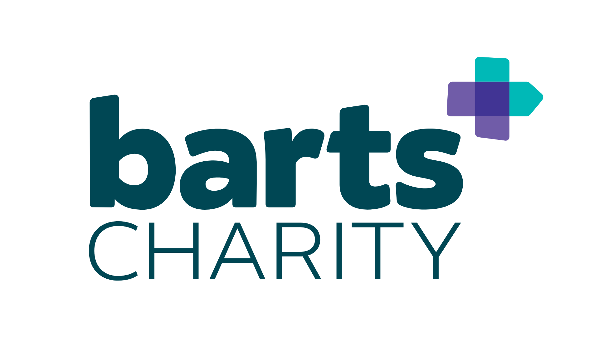

Barts Charity Doctoral Training Programme: Project Proposal Form

1. Project Title:

2. Supervisory Team:
Primary Supervisor |  | Secondary Supervisor
Name: |  | Name:
Institute: |  | Institute:
Email: |  | Email:
Details of any other members of supervisory team:

3. Lay summary (250 words)

4. Project proposal (1500 words)
To include Background, Hypothesis, Aims and Objectives, Experimental Approach and/or Study Design, Research Outcomes, Potential Impact and Timeline.

5. East London (500 words)
Describe how the project will address health inequalities and disease burden experienced by the East End population and align with the ethos of the Barts Charity Doctoral Training Programme

6. Skills training (300 words)
Provide details of skills and other training that the PhD student undertaking the project will receive. Do NOT detail generic training that is available to all QMUL students.

7. Experience of Supervisory Team

Primary Supervisor
Total number of PhD students supervised as primary supervisor:
Number of current PhD students as primary supervisor:
Number of current PhD students as secondary supervisor:
Number of PhD students as primary supervisor who submitted on time:

Details of any PhD students you supervised who failed to complete their PhD on time:
(name, date of initial enrolment and thesis submission, reason for late submission or withdrawal from programme)

Date of most recent PhD supervisor training:

Details of additional training undertaken that is directly relevant to PhD student development and support:

Secondary Supervisor
Total number of PhD students supervised as primary supervisor:
Number of current PhD students as primary supervisor:
Number of current PhD students as secondary supervisor:
Number of PhD students as primary supervisor who submitted on time:

Details of any PhD students you supervised who failed to complete their PhD on time:
(name, date of initial enrolment and thesis submission, reason for late submission or withdrawal from programme)

Date of most recent PhD supervisor training:

Details of additional training undertaken that is directly relevant to PhD student development and support:

8. Promoting a positive research culture (300 words)
Describe how the supervisory team will nurture a positive research culture, including to promote student wellbeing within their research groups.

9. Contribution to the Doctoral Training Programme
In what areas can the supervisor team contribute skills or other training to the Doctoral Training Partnership? List topics where you would be willing to provide seminars, workshops, tutorials, etc to the student cohort.

10. Approvals
Does the planned research require ethical or other approvals? | Y/N
Are these in place? | Y/N
If yes to the above questions, please provide details:

